Word Template for AIST Conference Proceedings

Author A¹, Author B², Author C²

¹Company Name
Street Address, State, Country, ZIP/Postal code
Phone:
Email:

²Company Name
Street Address, State, Country, ZIP/Posttal code
Phone:
Email:

(Note: Please add more authors in the same format if necessary)
ABSTRACT
The abstract should be short – 150 words or less. Authors should follow the general guidelines – paper size, margins, font and font size, format of headings, Table and Figure formatting etc. – as specified in the Author Guidelines posted on the Galvatech 2026 website under Author Resources. Differences between the guidelines for conference papers and extended abstracts will be specified below, as required. The overall length of your extended abstract – including references – should be between three and four pages.

Keywords: Term A, Term B, Term, C, Term D (Note: Authors are not limited to only 4 terms)
INTRODUCTION
Use this section to briefly introduce your subject, provide some essential background information and provide a well defined objective for your investigation. Please confine yourself to several paragraphs.
methodology
Provide a summary of the methodology used in the development of your contribution, be they experimental, computational or otherwise
Results and DISCUSSION
The Results and Discussion section should comprise the bulk of your contribution and can contain such items as tables or figures, formatted per the Author Guidelines. Examples of tables, equations and figures are provided below, with exemplar caption formatting (Tables and Figures) and equation numbering.

Table I: Selected Chemistry of Steels, wt %
Product  Identification | Processing | C | Mn | S | Ca | Al | N | Si | Other
Medium-Carbon  Heat-treated | Austenitized  + Quenched | 0.190 to 0.210 | 1.35 to 1.40 | 0.0001 to 0.0015 | 0.0008 to 0.0023 | 0.050 to 0.059 | 0.0023 to  0.0049 | 0.230 to  0.260 | Nb, Ti,  B
Medium-Carbon  High Sulfur | Hot Rolled | 0.160 to 0.170 | 1.09 to 1.14 | 0.0018 to 0.0076 | 0.0017 to 0.0026 | 0.023 to 0.028 | 0.0073 to 0.0108 | 0.020 to 0.050 | V
Low-Carbon  High Sulfur | Hot Rolled | 0.070 to 0.077 | 1.22 to 1.30 | 0.0016 to 0.0050 | 0.0013 to 0.0025 | 0.030 to 0.044 | 0.0081 to 0.0108 | 0.174 to 0.240 | V

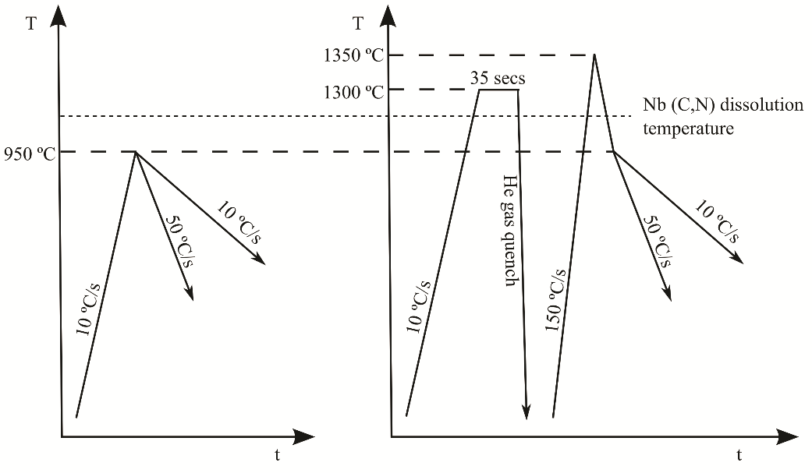
Figure 1. Steel heat treatment time-temperature profiles.
CONCLUSIONS
Briefly summarize the principal conclusions of your contribution in either a brief paragraph or using succinct bullet points.
REFERENCES
- World Steel Association, “Top Steel-Producing Companies 2020,” 1 June 2021, https://www.worldsteel.org/steel-by-topic/statistics/top-producers.html.
- S. Abraham, J. Raines and R. Bodnar, “Development of an Inclusion Characterization Methodology for Improving Steel Product Cleanliness,” AIST Transactions, Vol. 11, No. 2, 2014, pp. 219–234.
- J.B.A.F. Smeulders, “Roll Cooling and Lubrication in Cold Rolling,” The Making, Shaping and Treating of Steel®, Flat Products Volume, Association for Iron & Steel Technology, Warrendale, Pa., USA, 2014, Chapter 13.2.
- C. Homsher-Ritosa, “Influence of Processing Parameters and Alloying Additions on the Mechanically Determined No-Recrystallization Temperature in Niobium Microalloyed Steels,” Ph.D. thesis, Colorado School of Mines, 2016, p. 55.
- Standard Specification for Plates, Carbon Steel, Structural Quality, Furnished to Chemical Composition Requirements, ASTM Standard A830/A830M-18, ASTM International, West Conshohocken, PA, USA, 2018, DOI: 10.1520/A0830_A0830M-18.

